Course Title:
Operating System

Project Title:
System Call for Ice Cream Factory Problem

Group Members:

Huzaifa Bin Saif 22I-0605
Zain Islam 22I-1391

OBJECTIVE:
This project has to goal to simulate an Ice Cream Factory where multiple customers are handled using system calls and account for conditions such as deadlock and race condition.

PROJECT DESCRIPTION:

Firstly, the system call prints a string and customer ID according to the different activities performed by the customer such as departure or arrival of customer. Furthermore, the problem of occurrence of deadlock is solved by using threads and semaphores.
The flow of the program is as follows:
- First, Customer gets an ID
- Then, he moves towards ticket counter and gets his ticket checked
- After that, progress towards flavor counter and chooses a flavor
- Afterwards, he proceeds towards topping counter and chooses a topping
- Next, departs for the payment counter,
- At last, he exits.

Note: System Calls were implemented using the following link: https://www.youtube.com/watch?v=AP-tBd84vbM

Source Code:

#include <stdio.h>
#include <stdlib.h>
#include <unistd.h>
#include <pthread.h>
#include <semaphore.h>
#include <string.h>
#include <sys/syscall.h>
#include <linux/kernel.h>

#define FLAVOR_1_PRICE 1.05
#define FLAVOR_2_PRICE 2.00
#define FLAVOR_3_PRICE 1.67
#define TOPPING_1_PRICE 0.8
#define TOPPING_2_PRICE 0.5

int total_tickets = 30, flavors[3] = {29, 34, 18}, toppings[2] = {20, 34};
double total_revenue = 0.0;

sem_t ticket_counter, flavor_counter, flavor1, flavor2, flavor3, topping_counter, topping1, topping2, payment_counter;

void *process_customer(void *customer_id);

int main() {
int num_customers;

printf("\nEnter Number Of Customers [1-%d]: ", total_tickets);
scanf("%d", &num_customers);
printf("\n");

if (num_customers > total_tickets || num_customers <= 0) {
printf("\nInvalid Input!\n");
return 0;
}

int customer_ids[num_customers];

for (int i = 0; i < num_customers; i++) {
customer_ids[i] = i + 100;
}

sem_init(&ticket_counter, 0, 1);

sem_init(&flavor_counter, 0, 3);
sem_init(&flavor1, 0, 1);
sem_init(&flavor2, 0, 1);
sem_init(&flavor3, 0, 1);

sem_init(&topping_counter, 0, 2);
sem_init(&topping1, 0, 1);
sem_init(&topping2, 0, 1);

sem_init(&payment_counter, 0, 1);

pthread_t customers[num_customers];

for (int i = 0; i < num_customers; i++) {
pthread_create(&customers[i], NULL, process_customer, (void*)&customer_ids[i]);
}

for (int i = 0; i < num_customers; i++) {
pthread_join(customers[i], NULL);
}

printf("\nBusiness Journal - At Closing\n");
printf("Number Of Customers: %d", num_customers);
printf("\nRevenue Generated: $%f", total_revenue);
printf("\nTickets Remaining: %d\n", total_tickets);

sem_destroy(&ticket_counter);
sem_destroy(&flavor_counter);
sem_destroy(&flavor1);
sem_destroy(&flavor2);
sem_destroy(&flavor3);
sem_destroy(&topping_counter);
sem_destroy(&topping1);
sem_destroy(&topping2);
sem_destroy(&payment_counter);

return 0;
}

void *process_customer(void *customer_id) {
int id = *(int*)customer_id;
double bill = 0.0;

sem_wait(&ticket_counter);

if (total_tickets <= 0) {
printf("\nCustomer[%d]: Leaving Shop. [Reason]: Tickets Finished\n", id);
syscall(333, "Leaving Shop. [Reason]: Tickets Finished\n", id);
sleep(1);
pthread_exit(NULL);
}

total_tickets--;
printf("Customer[%d] Got Ticket.\n", id);
syscall(333, "Got Ticket.\n", id);

sem_post(&ticket_counter);

sleep(2);

sem_wait(&flavor_counter);

if (flavors[0] <= 0 && flavors[1] <= 0 && flavors[2] <= 0) {
printf("\nCustomer[%d]: Leaving Shop. [Reason]: Flavors Finished\n", id);
syscall(333, "Leaving Shop. [Reason]: Flavors Finished\n", id);
sleep(1);
pthread_exit(NULL);
} else {
sem_wait(&flavor1);

if (flavors[0] > 0) {
flavors[0]--;
bill += FLAVOR_1_PRICE;
printf("\nCustomer[%d]: Got Flavor[0].\n", id);
syscall(333, "Got Flavor[0].\n", id);
sleep(1);
}

sem_post(&flavor1);

sem_wait(&flavor2);

if (flavors[1] > 0) {
flavors[1]--;
bill += FLAVOR_2_PRICE;
printf("Customer[%d]: Got Flavor[1].\n", id);
syscall(333, "Got Flavor[1].\n", id);
sleep(1);
}

sem_post(&flavor2);

sem_wait(&flavor3);

if (flavors[2] > 0) {
flavors[2]--;
bill += FLAVOR_3_PRICE;
printf("Customer[%d]: Got Flavor[2].\n", id);
syscall(333, "Got Flavor[2].\n", id);
sleep(1);
}

sem_post(&flavor3);

if (bill == 0.0) {
printf("\nCustomer[%d]: Leaving Shop. [Reason]: Flavors Finished\n", id);
syscall(333, "Leaving Shop. [Reason]: Flavors Finished\n", id);
sleep(1);
pthread_exit(NULL);
}
}

printf("\nCustomer[%d]: Got Flavor(s). Leaving Flavor Counter\n", id);
syscall(333, "Got Flavor(s). Leaving Flavor Counter\n", id);

sem_post(&flavor_counter);

sem_wait(&topping_counter);

sem_wait(&topping1);

if (toppings[0] > 0) {
toppings[0]--;
bill += TOPPING_1_PRICE;
}

sem_post(&topping1);

sem_wait(&topping2);

if (toppings[1] > 0) {
toppings[1]--;
bill += TOPPING_2_PRICE;
}

sem_post(&topping2);

printf("\nCustomer[%d]: Leaving Topping Counter.\n", id);
syscall(333, "Leaving Topping Counter.\n", id);

sem_post(&topping_counter);

sleep(2);

sem_wait(&payment_counter);

total_revenue += bill;

printf("\nCustomer[%d]: Billed: $%f.\n", id, bill);
char log_msg[100];
sprintf(log_msg, "Billed: $%f.\n", bill);
syscall(333, log_msg, id);

sem_post(&payment_counter);

sleep(2);

printf("\nCustomer[%d]: Leaving Ice-Cream Shop.\n\n", id);
syscall(333, "Leaving Ice-Cream Shop.\n\n", id);

return NULL;
}

Output:

. Enter customers from the range of 1-30. In this example 5 customers have been added.

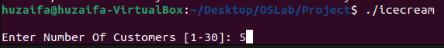
. Customers are served

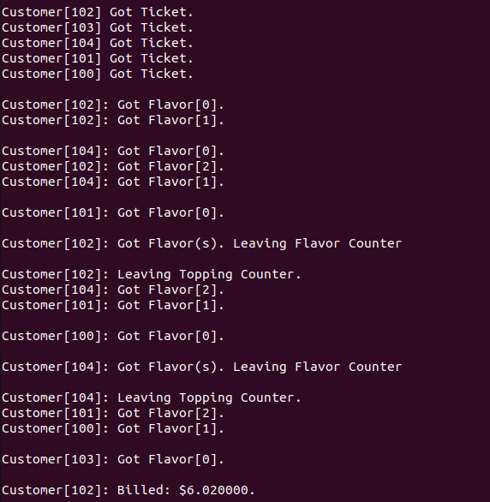
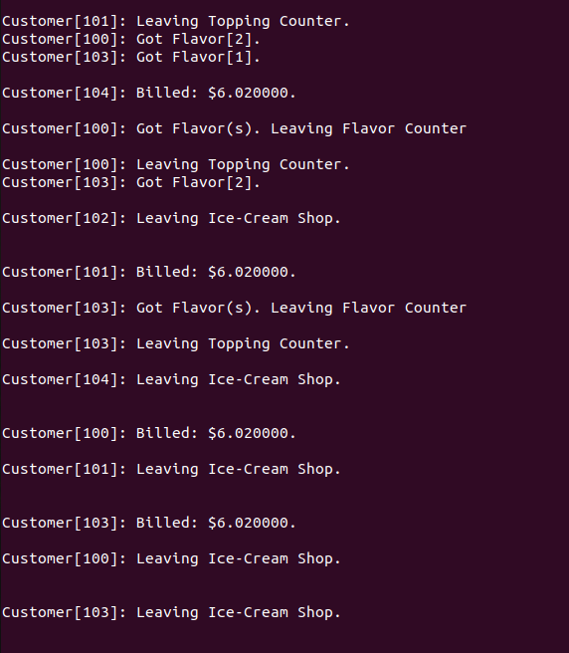

. Finally the report is generate of end of day sales

